|  |
| --- |
| Originally Posted by **DrJeff** [View Post](https://www.diyelectriccar.com/forums/showthread.php?p=1012569#post1012569)  *Radiator Bypass Valve  3 Way Valve  A = RD-WH ; VS+ ; Pwr  D = TN-BK ; PosIn ; PWM  F = TN-DB ; FB ; Pos  C = BK ; VS- ; Gnd    Chiller Bypass Valve  3 Way Valve  A = RD-YE ; VS+ ; Pwr  D = TN-DG ; PosIn ; PWM  F = WH-BN ; FB ; Pos  C = BK ; VS- ; Gnd    Four Way Valve  A = RD-GY ; VS+ ; Pwr  D = WH-DG ; PosIn ; PWM  F = WH-DB ; FB ; Pos  C = BK ; VS- ; Gnd* |

I assume the 3-way valves are identical in terms of hardware, but I'll check.  
  
Thanks for that information. I played around with them and found out the following.  
  
  
Update: after looking at the results of the 3-port I realized there was an error in the 4-port mapping. Updated the text below.  
  
  
So in words:  
  
Nb. outlets numbered clockwise starting with 1 at 12 o'clock.  
  
For the 4 way valve:  
  
A = 12V+ and C = ground => mixing so connects 1+2+3+4  
  
A = 12V and C + D = ground => turns clockwise to connect 1+3 and 2+4  
  
A + D = 12V and C = ground => turns counter clockwise to connect 1+2 and 3+4  
  
  
  
For the 3 way valve:  
  
A = 12V+ and C = ground => mixing so connects 1+2+3  
  
A = 12V and C + D = ground => connects 1+3  
  
A + D = 12V and C = ground => connects 2+3

Radiator Bypass Valve  
3 Way Valve  
A = RD-WH ; VS+ ; Pwr  
D = TN-BK ; PosIn ; PWM  
F = TN-DB ; FB ; Pos  
C = BK ; VS- ; Gnd  
  
Chiller Bypass Valve  
3 Way Valve  
A = RD-YE ; VS+ ; Pwr  
D = TN-DG ; PosIn ; PWM  
F = WH-BN ; FB ; Pos  
C = BK ; VS- ; Gnd  
  
Four Way Valve  
A = RD-GY ; VS+ ; Pwr  
D = WH-DG ; PosIn ; PWM  
F = WH-DB ; FB ; Pos  
C = BK ; VS- ; Gnd  
  
Coolant Pump 2  
1 = OG-YE ; Batt ; 15A  
3 = GY-BN ; PWM  
4 = GY-RD ; FB  
2 = BK ; Gnd  
  
Coolant Pump 1  
1 = OG-BN ; Batt  
3 = GY-WH ; PWM  
4 = GY-PK ; FB  
2 = BK ; Gnd  
  
Coolant Pump 3  
1 = OG-RD ; Batt  
3 = GY-DG ; PWM  
4 = GY-DB ; FB  
2 = BK ; Gnd

The coolant pumps out of the Tesla (2015 Model S 70D) are VariMax Intercooler Pumps. Listed for "C4 Corvette 1985-1996" by [Lingenfelter Engineering](http://www.lingenfelter.com/product/L330070000.html).  
  
They have four control lines...  
+12v and GND, PWM and Signal.  
PWM is a 5v, 2Hz signal (2 cycles per second)  
(switching on for 0.25 secs, and off for 0.25 secs will set speed to 50%)  
Signal is PWM-like and indicates the pump speed. **I controlled it with a simple 5v digital pin on an Arduino.  
  
"- Target flow rate 720 LPH @ 70 kPa   
- Inlet / Outlet connection: 19 MM Barb   
- Motor syle: Brushless   
- Operating voltage: 8-16 VDC   
- Maximum amp draw: 7.3 Amp with RSDS Software"  
  
It has soft start which means that on applying 12v or adjusting the PWM signal it slowly speeds up or slows down as necessary.

The Tesla has a number of coolant diverter valves, one of which is 4 way : TMN 6007370-00-B (two ins, switched between two outs), and others are 3 way : TMN 6007384-00-B (one in, switching between two outs).  
  
The 4-port valve is used to connect the coolant flow into 1 continuous large loop or separate it into 2 smaller loops. Useful for heating/cooling just the battery unit - distinct from whatever the temp of the driveunit. The 3-oprt is used to bypass the radiator and another to bypass the coolant chiller.  
  
The valves are listed as PWM controlled, but this is not correct. There are four wires, +12v and Gnd, Signal and Control. Rather than being PWM, Control should switch between Ground and +12v to switch flow from one outlet to the other (for both the 3 and 4 port valves). Signal indicates value position - but need not be connected for valve control purposes.  
  
3-Port  
TMN 6007384-00-B  
Electrical Actuated 3/4" 3-port  
TMN G9361-0R010  
H42M-9000-000  
  
4-Port  
TMN 6007370-00-B  
Electrical actuated 3/4" 4-port  
Invensys 15B16  
Motor actuator (12v)  
127-00033-001 (90)  
H42M-8000-000

The motor direction is controlled by sending a HIGH or LOW signal to the drive for each motor (or channel). For example for motor one, a HIGH to IN1 and a LOW to IN2 will cause it to turn in one direction, and  a LOW and HIGH will cause it to turn in the other direction.

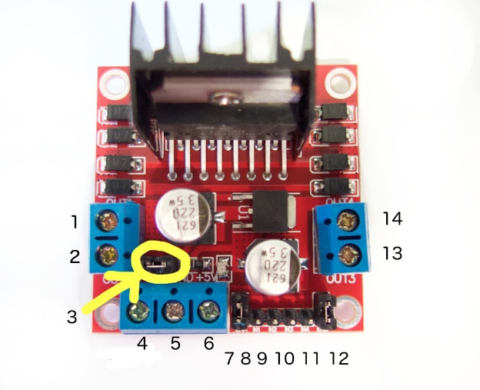

1. DC motor 1 "+" or stepper motor A+
2. DC motor 1 "-" or stepper motor A-
3. 12V jumper - remove this if using a supply voltage greater than 12V DC. This enables power to the onboard 5V regulator
4. Connect your motor supply voltage here, maximum of 35V DC. Remove 12V jumper if >12V DC
5. GND
6. 5V output if 12V jumper in place, ideal for powering your Arduino (etc)
7. DC motor 1 enable jumper. Leave this in place when using a stepper motor. Connect to PWM output for DC motor speed control.
8. IN1
9. IN2
10. IN3
11. IN4
12. DC motor 2 enable jumper. Leave this in place when using a stepper motor. Connect to PWM output for DC motor speed control.
13. DC motor 2 "+" or stepper motor B+
14. DC motor 2 "-" or stepper motor B-